Fire Safety Plan
Building Emergency Response Plan

< INSERT PHOTO OF MAIN APPROACH SIDE/FRONT OF BUILDING >
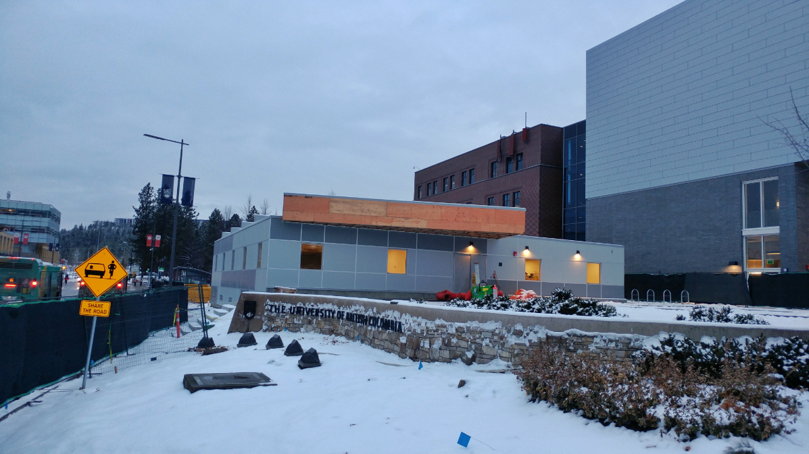

< Building Name >

< Building Address >
Kelowna, BC V1V 1V7

To comply with the Freedom of Information and Protection of Privacy Act (FIPPA), the information within this document should only be retained as long as required, should only be used for the authorized purpose it was collected for, and access should be restricted to a needs only basis (i.e. only those staff and faculty of a particular building that the Building Emergency Response Plan was developed for should have access to it).

To be updated annually or as needed to include personnel and/or facility changes

Last Revision Date: 2020/10/28

Health, Safety & Environment
hse.ok.ubc.ca

Table of Contents
Table of Contents i
Emergency and Safety Contacts 1
Objectives 2
Emergency Evacuation Concept 3
Building Features 4
Life Safety Systems 7
Contacts - Building Emergency Directors and Emergency Wardens 11
Persons Requiring Assistance 12
Responsibilities 13
In the Case of a Building Fire 15
In the Case of an Earthquake 20
In the Case of Explosions or Fires, Gas Leaks, or Release of Hazardous Materials 26
In the Case of a Bomb Threat 29
In the case of an Active Shooter 30
Fire Evacuation Drills – Procedures and Records 32
Appendix 1: UBCO First Aid Program 33
Appendix 2: Emergency Keyplan 34
Appendix 3: Building Site Plan 35
Appendix 4: Inspection, Testing and Maintenance of the Building Fire Protection and Life Safety Systems 36
Appendix 5: BC Fire Code 2018 Excerpt 45
Appendix 6: Operating a Fire Extinguisher 48
Appendix 7: Persons Requiring Assistance 49
Appendix 8: Personal Emergency Plan Template 54
Appendix 9: Definitions 55

Emergency and Safety Contacts

IN THE EVENT OF AN EMERGENCY, DIAL 911

Emergency Numbers
BC GAS LEAKS AND ODOURS | 1-800-663-9911
UBCO EMERGENCY / FIRST AID / CAMPUS SECURITY | 250-80(7-8111)
UBCO DEPT. OF HEALTH, SAFETY & ENVIRONMENT | 250-80(7-8111)
HAZARDOUS MATERIALS RESPONSE | 911
POISON CONTROL CENTRE | 1-800-567-8911
EMERGENCY MANAGEMENT BC | 1-800-663-3456
BC WILDFIRE REPORTING | 1-800-663-5555  OR *5555 (CELL PHONE)
NON-EMERGENCY NUMBERS
UBCO CAMPUS SECURITY (NON-EMERGENCY) | 250-80(7-9236)
UBCO DEPT. OF HEALTH, SAFETY & ENVIRONMENT | 250-80(7-8859)
UBCO FACILITIES MANAGEMENT | 250-80(7-9272)
EMERGENCY MANAGEMENT BC (HEADQUARTERS) | 1-250-952-4913
RCMP (NON-EMERGENCY) | 250-762-3300
FIRE DEPARTMENT (NON-EMERGENCY) | 250-469-8801
KELOWNA GENERAL HOSPITAL EMERGENCY DEPARTMENT | 250-862-4485

Objectives

The Fire Safety Plan has three primary objectives, as follows:

- Fire Hazard Control: To prevent the occurrence of fire by the control of fire hazards in the building.
- Fire Protection System Maintenance: To ensure the operation of fire protection systems by establishing maintenance procedures.
- Emergency Evacuation: To provide a systematic method of a safe and orderly evacuation of a building or area, by any or all of its occupants, in the case of a fire or other emergency.

A Fire Safety Plan also provides:

- Infrastructure Creation: To facilitate training and necessary building evacuations, an infrastructure of key personnel will be established comprised of strata owners and/or tenants.
- Training: To provide a manual upon which fire drills and general fire safety training will be based. This manual is intended to be utilized as a training aid, prior to an emergency occurring, so that these procedures are secondary in nature. The explicit instructions ensure that the intent of the procedures will not be misinterpreted. It is NOT intended to be solely relied upon during an emergency due to the complex nature of its instructions

A priority in any emergency situation is to save lives, minimize injuries, and reduce damage to property.

Emergency Evacuation Concept

Trained supervisory staff can be of great value in directing and assisting the orderly movement of people in the event of a fire and performing fire control until the fire department arrives.

Evacuation procedures relying heavily on supervisory staff are complex, in that such staff require continued training, frequent drilling, and must be continuously on the premises in order to fulfil their responsibilities during an emergency. Following the implementation of the plan, the time required for continued training and drilling and the coordination necessary to maintain supervisory staff on the premises is extreme.

Based on these facts, the evacuation objective outlined in this guide is met simply and realistically without evacuation control officers or the emergency director’s involvement in evacuation control.

Evacuation Sequence

During an emergency, a fire alarm will sound, and all occupants will exit the building via a safe exit. Persons with disabilities should proceed with their assistants (if available) to the nearest safe exit. The Emergency Director should be available to respond to the premises during regular hours after being contacted by the fire department (Note: Campus Security is available to respond to premises after regular hours).

The instructions for occupants “Emergency Procedures”, posted prominently on each floor area, provide quickly read information on procedures to follow in the event of a fire. Use of this concept should ensure a systematic method of safe and orderly evacuation of the building in the event of a fire.

Building Features

This building was built in <insert year> to conform to the B.C. Building Code Regulations Act and the City Regulations in effect at the time.

Construction Materials
Outside Construction / Finishing: | < >
Inside Construction / Finishing: | < >
Windows: | < >
Roof: | < >  Access via: < insert means of accessing roof >

Provisions for Firefighting:
 | Hydrant to Building: |  | < > metres |  | Hydrant to Building’s Fire Dept. Connection: |  |  | < > metres
 | Fire Alarm Systems: | ☐ |  | Exit Signs: |  | ☒ | Emergency Lighting: |  | ☐
 | Panic Hardware: | ☐ |  | Standpipe & Hose Systems: |  | ☐ | Fire Department Access: |  | ☐

Exits:
 | Number of Exits: | < > | Max Travel Distance: | < > metres | Exit Width Required: | < > mm | Provided: | < > mm

Washrooms:
 | Female: | < > |  | Male: | < >
 | Gender Neutral: |  | < >

FLOOR/LOCATION | DESCRIPTION OF USE
< > Floor: | < describe activities that occur in the building floor-by-floor (can group floors having the same activity(ies)) >

Critical Shut-off Locations

 | LOCATION | ROOM NUMBER
Main Interior Fire Sprinkler Water Shut-Off | < insert room name e.g. Mechanical Room  + photo > | <bldg + room #>
Main Interior Water Shut-Off | < insert room name e.g. Mechanical Room  + photo > | <bldg + room #>
Main Electrical Disconnect | < insert room name e.g. Mechanical Room  + photo > | <bldg + room #>

System Repair, Service & Emergency Contacts

Fire Safety Equipment | Company Name | Phone Number
Sprinkler System | UBCO Facilities Management | 250-807-9272
Fire Alarm | UBCO Facilities Management | 250-807-9272
Portable Extinguishers | UBCO Facilities Management | 250-807-9272
Emergency Lighting | UBCO Facilities Management | 250-807-9272
Chimneys & Flues | UBCO Facilities Management | 250-807-9272
Exhaust Ducts | UBCO Facilities Management | 250-807-9272
Heating, Ventilation & Air Conditioning | UBCO Facilities Management | 250-807-9272
Watchperson Service | UBCO Facilities Management | 250-807-9272
Building Manager | UBCO Facilities Management | 250-807-9272
Building Owner/Rep. | UBCO Facilities Management | 250-807-9272

NOTE: refer to Appendix 4 for Inspection, Testing and Maintenance of the building fire protection and life safety systems.

Fire Detection & Alarm System

The Fire Alarm System utilizes a/an < insert alarm manufacturer name and model #, # of stages, is control panel addressable? >, located in the < insert room name > room. This system is equipped with the following strategically placed devices:

Device Type | Location
manual alarm pull stations | < insert location(s) or “none” >
smoke detectors | < insert location(s) or “none” >
heat detectors | < insert location(s) or “none” >
sprinkler activation & tamper devices | < insert location(s) or “none” >

In the event the fire alarm is activated, it should not be reset until directed to do so by Fire Department officials. For more information on how to reset your Fire Alarm system, contact Facilities Management or the Fire Department.

 | LOCATION | ROOM NUMBER
Fire Alarm Control Panel | < insert room name e.g. Mechanical Room  + photo > | <bldg + room #>

< insert photos of annunciator panel & fire alarm control panel >

Zone # | Index Description
1 | < “single zone for all devices” or list each zone with location description >

Activation of any initiating device will cause a General Alarm throughout the building and a fire signal to be sent to the Fire Department who is monitoring this complex. The fire department should be notified immediately by dialing 911.

Life Safety Systems

Sprinkler Systems
This building is protected by a standard wet type automatic sprinkler system. < OR > There are no sprinklers in this building.

Fire Alarm System
Fire alarm pull stations are located at all exits. The building’s fire alarm system is connected to the campus wide fire alarm system. Fire alarm system is monitored by the Kelowna Fire Department through the 911 dispatch Centre (E-Comm). Fire alarm system maintenance is managed by UBCO Facilities Management. The locations of fire alarm pull stations are indicated in APPENDIX 2: Emergency Keyplans. Heat detectors are located < insert location(s) or state that there are not any >. Smoke detectors are located < insert location(s) or state that there are not any >.

Exit Systems
< sample text follows - replace with appropriate descriptions > There are two stairwells at the NW corner and two stairwells at the SW corner of the building that provide egress between the lower floor and the main floor. There is one NE stairwell that is not classified as an approved exit and is for occupant convenience only.

On the lower floor there are three NE exits (two from the lobby area and one from the field amenity building); one SE exit (from the field amenity building), and two south exits (end of corridor and from gymnasium). On the main floor there is one NE exit (main entry), four north exits (along concourse), two NW exits (from stairwells), and two SW exits (from stairwells), all of which provide egress to the outside.

Refer to APPENDIX 2: Emergency Keyplans to view maps showing the building evacuation routes and exits.

Emergency Lighting
< modify as necessary > Emergency lighting has been installed to cover all common corridors, stairwells and exit signage. Maintenance of emergency lights is handled by UBCO Facilities Management.

Emergency Generator
There is no emergency generator in the ___________ Building. < OR > In the event of an A/C power failure, the < select > Central Heating Plant / building’s emergency generator will supply emergency power in the common areas. This generator unit provides power to emergency lighting, exit signage, elevators and all related emergency equipment.

Portable Fire Extinguishers
There are 5 lb ABC multi-purpose dry chemical portable fire extinguishers located strategically (i.e. visible and accessible) throughout the building. Refer to APPENDIX 5: Operating a Fire Extinguisher for instructions on the proper use of fire extinguishers. Refer to APPENDIX 2: Emergency Keyplans for locations of portable fire extinguishers.

Elevators
There are no elevators in the ___________ Building. < OR > There is one elevator located in the NE corner of this building to serve its occupants (2000 lbs. capacity). This elevator is not firefighter-rated and upon fire alarm activation will operate as usual and should not be used. All occupants will use the exit stairwells as means of egress. The elevator should be locked out by Facilities Management when appropriate.

Fire Hydrants
< sample text follows - replace with appropriate descriptions > There is one fire hydrant located to the north of the building in the turnaround circle on Athletics Court and one fire hydrant located to the SE of the building on the unnamed back access laneway (refer to APPENDIX 3: Building Site Plan for locations of fire hydrants in the vicinity of the building).

Fire Department Connections
There is no fire department connection on this building. < OR > One 2½″ fire department connection is located by the main entrance off Athletics Court (NW side of building).

Fire Department Access
Fire Department personnel can access this building via < modify as necessary > the main entrance off University Way.

Pre-Designated Meeting Area(s)
The Pre-Designated Meeting Areas (PDMAs)/muster stations for this building are:

< INSERT APPROPRIATE MAP HERE / SAMPLE BELOW >
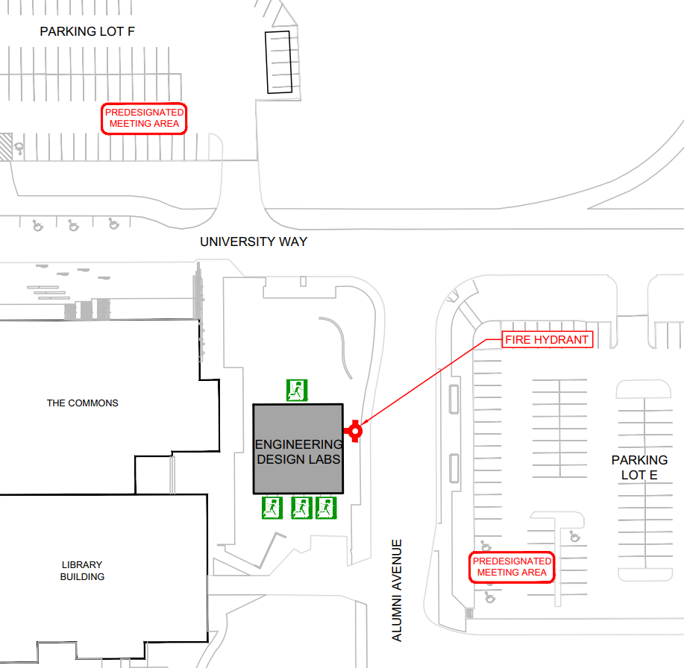

< EDIT PDMA LOCATION(S) AS NECESSARY >
- main exit - north - assemble in Parking Lot F across University Way
- lab and mechanical room exits - south - assemble in Parking Lot E across Alumni Avenue
< IN SITUATIONS WHERE THERE ARE MORE THAN ONE PDMA FOR A BUILDING, CHOOSE ONE OF THE PDMAs TO BE DESIGNATED AS THE LOCATION WHERE EMERGENCY WARDENS/RESIDENCE ADVISORS CHECK IN WITH THE BUILDING EMERGENCY DIRECTOR AFTER SWEEPING THEIR AREA >

As the building is evacuated and Emergency Wardens complete their area sweeps, they will check-in with the Building Emergency Director at the PDMA in Parking Lot F across University Way.

Do not block the main driveways into the complex.
Do not block traffic flows.

BE AWARE OF ONCOMING EMERGENCY VEHICLES.

Contacts - Building Emergency Directors and Emergency Wardens

POSITION | PHONE NUMBER
 | WORK | OTHER (e.g. mobile)
Building Emergency Director  Name: Campus Security (interim) | 250-807-8111
Deputy Building Emergency Director  Name: Dept. of Health, Safety & Environment (interim) | 250-807-8821
Emergency Warden - Level 1  Name: Campus Security (interim) | 250-807-8111
Emergency Warden - Level 1  Name: Dept. of Health, Safety & Environment (interim) | 250-807-8821

NOTE: Do not include personal home phone numbers on this list. This document is a workplace document and it is meant for UBC faculty and staff, so it must not include any external personal contact information.

Persons Requiring Assistance

Locations/ Plans

If Persons requiring assistance are in your workplace, please refer to Appendix 6. Indicate on the table below, Building Occupants in your office area that require assistance during an emergency evacuation.

NAME | OFFICE AREA | PHONE NUMBER | PROVIDE SUMMARY OF PERSONAL EMERGENCY PLAN  (See Appendix 7 for full plan)
Name: (Example)  John Smith | 2nd Floor, Room 200 | 604-822-xxxx | Matt Smith will meet John Smith at John’s desk. Matt will assist John evacuate the building.
Name:
Name:
Name:
Name:

NOTE: To respect personal privacy, please obtain consent from each of the individuals indicated on the table above prior to posting a public copy of the Building Emergency Response Plan on a safety or information board within your building. If full consent is not available, please remove this page prior to posting. Refer to the first page of the BERP for information on privacy.

Responsibilities

Building Emergency Director

The Building Emergency Director supervises and maintains the BERP.

The Building Emergency Director recruits the Emergency Wardens. Having one (1) alternate for each position (Building Emergency Director and Emergency Wardens) is required; however, having two (2) alternates is recommended. In addition, the Building Emergency Director is responsible for the training of Emergency Wardens to perform their duties in fire prevention and emergency evacuation of the building. All Building Emergency Directors and Emergency Wardens should attend the Emergency Warden Training course, which is available through Health, Safety & Environment (submit training request to hse.ok@ubc.ca).

The Building Emergency Director maintains proper records of current Emergency Wardens, number and evacuation times of fire drills, fire and emergency incidents in the building, fire prevention activities, and a list of regular building occupants with disabilities. Full inspection and maintenance of the fire safety equipment is the responsibility of UBCO Facilities Management. However, if any occupant or Emergency Warden notices fire safety equipment in need of repair, they must notify the Building Emergency Director, who will contact Facilities Management to complete the repair(s).

Emergency Wardens

The Emergency Wardens must be familiar with their assigned areas to ensure a safe and orderly evacuation. That is, they are responsible for advising occupants on evacuating the building; however, Emergency Wardens must not lose valuable time attempting to convince occupants to leave if the occupants refuse to do so (never put yourself in danger while advising occupants). The names and location of occupants whom refuse to evacuate the building must be reported to the Building Emergency Director or Fire Department Incident Commander.

Emergency Wardens should check their floor or area* regularly for:
- Accumulation of combustible material, rubbish, or flammable liquids in excess of quantities allowed by permit.
- Dangerous ignition sources (e.g. worn extension cords, oily rags, overheating equipment).
- Hazardous equipment such as portable heaters. One must ensure heat emitting equipment is not next to cardboard boxes, paper, or any combustible materials. Lastly, one must never leave hazardous equipment unattended.
- Exit signs in good order and adequate lighting in public corridors and stairwells.
- Fire and exit doors and their self-closing hardware in good operating condition (Doors should not be wedged open under any conditions).
- Exit routes (means of egress) unobstructed.
- Portable fire extinguishers not obstructed, in good order and ready to use.
- Emergency Procedures maps are correct.

All fire hazards that are discovered must be reported to the Building Emergency Director immediately.

*According to WorkSafeBC, the Occupational Health and Safety (OHS) Regulation, section 3.3(b) requires formal OHS programs to include “provision for the regular inspection of premises, equipment, work methods and work practices, at appropriate intervals, to ensure that prompt action is undertaken to correct any hazardous conditions found.”, inspection duties can be shared amongst the Local Safety Team Members, University Health and Safety Committee members, Building Emergency Directors, and Emergency Wardens and local departments.

Building Occupants

Building Occupants must be familiar with their building evacuation route(s) and exit(s). During an evacuation, Building Occupants must follow instructions of Emergency Wardens and/ or the Building Emergency Director.

If you would require assistance during an evacuation, please notify Building Emergency Wardens or the Department of Health, Safety and Environment ahead of time to create an evacuation plan.

< INSERT CORRECT TEXT IN HIGHLIGHTED AREAS >

In the Case of a Building Fire

Building Emergency Directors - Instructions

If you discover a fire or explosion in the building:
- Activate the closest fire pull alarm immediately, if it is not activated already.
- Put on your safety vest.
- Walk through assigned areas and advise occupants to evacuate the building (DO NOT put yourself in danger).
- Knock on doors that are closed and continue moving. This does not mean you have to go inside every room and ask every person individually to evacuate the area.
- Urge people to stay calm and evacuate in a quick and orderly manner; however, ensure everyone is WALKING and NOT RUNNING.
- Close windows and doors that are near to you on your way out, but ONLY DO SO IF IT IS SAFE. This is to help prevent more oxygen from feeding the fire, to provide containment, and to slow down its spread.
- Assist anyone having difficulty evacuating, if possible, out of the nearest exit. If a person who uses a wheelchair cannot be evacuated to the outside through the north/main ground-level exit, they should be moved to the area of the building as far away as possible from the hazard; the Building Emergency Director and/or Emergency Wardens must relay the location of these occupants to emergency personnel so they know to prioritize evacuation of the individual.
- Upon exiting the building, ask evacuated occupants to proceed to the Predesignated Meeting Areas (muster stations). The Predesignated Meeting Areas are:
  - main exit - north - assemble in Parking Lot F across University Way
  - lab and mechanical room exits - south - assemble in Parking Lot E across Alumni Avenue
- Call 911
  - State your name.
  - Give the address where the fire is and the nearest intersection. The address of the _____________ Building is: 3317 University Way and the nearest intersection is: University Way and Alumni Avenue.
  - Provide information about the fire: what floor, how fast fire is spreading, people trapped, etc.
- Proceed to pre-determined meeting location for Building Emergency Directors and Emergency Wardens (e.g. at an open area that is a safe distance away from the building) and wait for Emergency Wardens to report information about the evacuation or about the building as required. The pre-determined meeting location for Building Emergency Directors and Emergency Wardens is in Parking Lot F to the north across University Way.
- Ensure all evacuation information reported from the Emergency Wardens is relayed to the Fire Department Incident Commander on site. (NOTE: Stay on scene until the Fire Department arrives).
- DO NOT ALLOW ANYONE TO RE-ENTER THE BUILDING until the Fire Department gives permission to do so. When ok, give the “all clear” to allow building occupants to re-enter the building.

Emergency Wardens – Instructions

The role of an Emergency Warden is to lead the evacuation of building occupants within their designated area.

If you discover a fire or explosion in the building:

- Activate the closest fire pull alarm immediately, if it is not activated already.
- Put on your safety vest.
- Walk through assigned areas and advise occupants to evacuate the building (DO NOT put yourself in danger).
- Urge people to stay calm and evacuate in a quick and orderly manner; however, ensure everyone is WALKING and NOT RUNNING.
- Knock on doors that are closed and continue moving. This does not mean you have to go inside every room and ask every person individually to evacuate the area.
- Close windows and doors that are near to you on your way out, but ONLY DO SO IF IT IS SAFE. This is to help prevent more oxygen from feeding the fire, to provide containment, and to slow down its spread.
- Assist anyone having difficulty evacuating, if possible, out of the nearest exit. If a person who uses a wheelchair cannot be evacuated to the outside through the north/main ground-level exit, they should be moved to the area of the building as far away as possible from the hazard; the Building Emergency Director and/or Emergency Wardens must relay the location of these occupants to emergency personnel so they know to prioritize evacuation of the individual.
- Ask evacuated occupants to proceed to the Predesignated Meeting Areas (muster stations) upon exiting the building. The Predesignated Meeting Areas are:
  - main exit - north - assemble in Parking Lot F across University Way
  - lab and mechanical room exits - south - assemble in Parking Lot E across Alumni Avenue
- Call 911:
  - State your name.
  - Give the address where the fire is and the nearest intersection. The address of the _______________ Building is: 3317 University Way and the nearest intersection is: University Way and Alumni Avenue.
  - Provide information about the fire: what floor, how fast fire is spreading, people trapped, etc.
- Proceed to pre-determined meeting location for Building Emergency Director and Emergency Wardens (e.g. at an open area that is a safe distance away from the building). The pre-determined meeting location for Building Emergency Directors and Emergency Wardens is in Parking Lot F to the north across University Way.
- Relay pertinent information to the Building Emergency Director or Fire Department Incident Commander at an open area that is a safe distance away from the building (e.g. refusals to leave, mobility-challenged occupants sheltering-in-place via horizontal evacuation).
  - All Emergency Wardens report information to Building Emergency Director and the Building Emergency Director reports all information to the Fire Department Incident Commander on site.
  - If Building Emergency Director is unavailable, the Building Fire Wardens can report directly to the Fire Department Incident Commander on site.
  - NOTE: Stay on scene until the Fire Department arrives.
- DO NOT ALLOW ANYONE TO RE-ENTER THE BUILDING until the Fire Department and the Building Emergency Director gives permission to do so. When ok, give the “all clear” to allow building occupants to re-enter the building.

Building Occupants – Instructions

NOTE: Building Occupants should follow instructions of Emergency Wardens during evacuation.
If you discover a fire or explosion in the building:

- Activate the closest fire pull alarm immediately, if it is not activated already.
- Follow instructions of Emergency Wardens during evacuation.
- Leave the immediate area, alert others, and move everyone away from the area of the fire.
- Close windows and doors that are near to you on your way out, but ONLY DO SO IF IT IS SAFE. This is to help prevent more oxygen from feeding the fire, to provide containment, and to slow down its spread.
- Urge people to stay calm and evacuate in a quick and orderly manner; however, ensure everyone is WALKING and NOT RUNNING.
- Proceed to evacuate, if possible, out of the nearest exit. If you require the use of a wheelchair and cannot be evacuated to the outside through the north/main ground-level exit, move to an area of the building as far away as possible from the hazard. This could mean moving to one of the south exits and exiting with assistance from another person, or it could mean sheltering in place in a different part of the building. If you must shelter in place, the Building Emergency Director and/or Emergency Wardens must relay your location to emergency personnel so they know to prioritize your evacuation. If you have not been able to communicate your location to a Building Emergency Warden, contact emergency services at 911 to inform them of your specific location within the building.

- Once outside of the building, proceed directly to the closest Predesignated Meeting Area (muster station) and wait for further instructions from the Building Emergency Director or an Emergency Warden. The Predesignated Meeting Areas are:
  - main exit - north - assemble in Parking Lot F across University Way
  - lab and mechanical room exits - south - assemble in Parking Lot E across Alumni Avenue
- If the building fire alarm has not been activated once you get outside, call 911.
  - State your name.
  - Give the address where the fire is and the nearest intersection. The address of the Engineering Design Lab Building is: 3317 University Way and the nearest intersection is: University Way and Alumni Avenue.
  - Provide information about the fire: what floor, how fast fire is spreading, people trapped etc.
- DO NOT RE-ENTER THE BUILDING until the Fire Department and/or the Building Emergency Director gives permission to do so. Follow instructions of Emergency Wardens during evacuation.

In the Case of an Earthquake

Building Emergency Directors - Instructions

If you are indoors:

During the shaking
- DROP onto the ground.
- Take COVER by getting under a sturdy desk or table (it is important to keep underneath of lab benches clear for this reason). Stay away from overhead windows, shelves, and heavy objects which may fall (e.g. ceiling mounted projectors).
- HOLD ON to the object that you are under so that you remain covered. Be prepared to move with the object until the shaking has finished. If you can’t get under something strong or if you are in a hallway, crouch against an interior wall and protect your head and neck with your arms.
- Stay indoors till the shaking stops and you are sure it is safe to exit (i.e. stay away from exterior walls, as it is more likely to sustain damage during an earthquake). In most buildings in British Columbia, you are safer if you stay where you are until the shaking stops.
After the shaking stops
- Count to 60 to allow debris to finish falling after the shaking stops and before attempting to exit.
- Assess your immediate surroundings for dangers. Determine whether it is safer to stay indoors or evacuate. Proceed with evacuating the building if it is safe.
- Begin Emergency Warden Evacuation Procedures.
  - Evacuate occupants in the area(s) that are assigned to you.
  - Urge people to stay calm, and to evacuate quickly and in an orderly manner. WALK, DO NOT RUN.
  - Assist anyone having difficulty evacuating, if possible, out of the nearest exit. If a person who uses a wheelchair cannot be evacuated to the outside through the north/main ground-level exit, they should be moved to the area of the building as far away as possible from the hazard. This could mean moving the person to one of the south exits and assisting with their exit down the stairs, or it could mean that the person would shelter in place in a different part of the building. If sheltering in place is the safest option, the Building Emergency Director and/or Emergency Wardens must relay the location of these occupants to emergency personnel so they know to prioritize evacuation of the individual.
  - Ask evacuated occupants to proceed to a Predesignated Meeting Area (muster station) upon exiting the building. The Predesignated Meeting Areas are:
    - main exit - north - assemble in Parking Lot F across University Way
    - lab and mechanical room exits - south - assemble in Parking Lot E across Alumni Avenue
  - Proceed to pre-determined meeting location for Building Emergency Directors and Emergency Wardens (e.g. at an open area that is a safe distance away from the building) and wait for Emergency Wardens to report information about the earthquake, the evacuation, or about the building as required. The pre-determined meeting location for Building Emergency Directors and Emergency Wardens is: Parking Lot F to the north across University Way.
  - Ensure that all evacuation information observed by yourself, as well as reported to you from the Emergency Wardens, is relayed to Emergency Responders on-site (e.g. Fire, Police or Ambulance).
  - DO NOT ALLOW ANYONE TO RE-ENTER THE BUILDING until the Fire Department or authorized UBC building officials give permission to do so. When ok, give the “all clear” to allow building occupants to re-enter the building.
  - Repeat DROP, COVER, AND HOLD procedure before resuming evacuation if an aftershock occurs during evacuation and you are still inside the building.

If you are outdoors:

During the shaking
- Stay outside if you are outdoors when the shaking starts, you should find a clear spot away from buildings, trees, streetlights, and power lines, then:
  - DROP to the ground,
  - COVER your head from falling debris. If you are in a crowded area, take cover where you won’t be trampled.
  - HOLD ON until the shaking stops.
After the shaking stops
- Count to 60 to allow debris to finish falling after the shaking stops.
- Assess your immediate surroundings for dangers.
- Stay away from overhead hazards such as fallen wires, trees, exterior walls, and heavy objects which may fall.
- Proceed to pre-determined meeting location for Building Emergency Directors and Emergency Wardens (e.g. at an open area that is a safe distance away from the building) and wait for Emergency Wardens to report information about the earthquake, the evacuation, or about the building as required. The pre-determined meeting location for Building Emergency Directors and Emergency Wardens is: Parking Lot F to the north across University Way.
- Ensure all evacuation information reported from Emergency Wardens is relayed to Emergency Responders on-site (e.g. Fire, Police, or Ambulance).
- DO NOT ALLOW ANYONE TO ENTER THE BUILDING until the Fire Department or authorized UBC building officials give permission to do so. When ok, give the “all clear” to allow individuals to enter the building. Do not enter your building to evacuate occupants and do not enter your building after the earthquake ends until you have been advised that the building is safe.

Post-earthquake instructions:

If available post-earthquake:
- Monitor for information and updates regarding the event.
- Information updates may be provided through UBC Alert and/or the UBC Okanagan Emergency website. Building occupants are encouraged to set up UBC Alert on their mobile phones and as such can visit http://emergency.ok.ubc.ca/ubcalert.html for more information.
- Emergency Response Personnel or Volunteers may be deployed to areas across campus to disseminate pertinent information in response to the event.

NOTE: Progress is currently being made by the University to address the area of Emergency Social Services (ESS) for the campus community. While the University is taking additional measures to help prepare the campus for disasters such as earthquakes, we also strongly encourage staff, faculty, residents and students to be personally prepared (e.g. having 72 hours emergency preparedness kits). Additional ESS related information will be provided once available.*

Emergency Wardens – Instructions

If you are indoors:

During the shaking
- DROP onto the ground.
- Take COVER by getting under a sturdy desk or table. Stay away from overhead hazards such as windows, shelves, and heavy objects which may fall (e.g. ceiling mounted projectors).
- HOLD ON to the object that you are under so that you remain covered. Be prepared to move with the object until the shaking has finished. If you can’t get under something strong, or if you are in a hallway, crouch against an interior wall and protect your head and neck with your arms. Stay indoors till the shaking stops and you are sure it is safe to exit. In most buildings in British Columbia, you are safer if you stay where you are until the shaking stops.
After the shaking stops
- Count to 60 to allow debris to finish falling after the shaking stops and before attempting to exit. Assess your immediate surroundings for dangers. Determine whether it is safer to stay indoors or evacuate. Proceed with evacuating the building if it is safe.
- Proceed with Emergency Warden Evacuation Procedures.
  - Evacuate occupants in the area(s) that are assigned to you.
  - Urge people to stay calm, and to evacuate quickly and in an orderly manner. WALK, DO NOT RUN.
  - Assist anyone having difficulty evacuating, if possible, out of the nearest exit. If a person who uses a wheelchair cannot be evacuated to the outside through the north/main ground-level exit, they should be moved to the area of the building as far away as possible from the hazard. This could mean moving the person to one of the south exits and assisting with their exit down the stairs, or it could mean that the person would shelter in place in a different part of the building. If sheltering in place is the safest option, the Building Emergency Director and/or Emergency Wardens must relay the location of these occupants to emergency personnel so they know to prioritize evacuation of the individual.
  - Upon exiting the building, ask evacuated occupants to proceed to the Predesignated Meeting Areas (muster stations). The Predesignated Meeting Areas are:
    - main exit - north - assemble in Parking Lot F across University Way
    - lab and mechanical room exits - south - assemble in Parking Lot E across Alumni Avenue
  - Meet the Building Emergency Director at the pre-determined location for Building Emergency Directors and Emergency Wardens (e.g. at an open area that is a safe distance away from the building) to give any additional information about the evacuation or about the building as required. The pre-determined meeting location for Building Emergency Directors and Emergency Wardens is: Parking Lot F to the north across University Way.
  - Ensure all necessary evacuation information is provided to the Building Emergency Director.
  - DO NOT ALLOW ANYONE TO RE-ENTER THE BUILDING until the Fire Department and the Building Emergency Director gives permission to do so. When ok, give the “all clear” to allow building occupants to re-enter the building.
  - Repeat DROP, COVER, AND HOLD procedure before resuming evacuation if an aftershock occurs during evacuation and you are still inside the building.

If you are outdoors:

During the shaking
- Stay outside if you are outdoors when the shaking starts, you should find a clear spot away from buildings, trees, streetlights, and power lines, etc. and then:
  - DROP to the ground.
  - COVER your head from falling debris. If you are in a crowded area, take cover where you will not be trampled.
  - HOLD ON until the shaking stops.
After the shaking stops
- Count to 60 to allow debris to finish falling after the shaking stops.
- Assess your immediate surroundings for dangers (e.g. fallen wires). Stay away from exterior walls and heavy objects which may fall.
- Meet the Building Emergency Director and Emergency Wardens at the pre-determined meeting location (e.g. at an open area that is a safe distance away from the building). The pre-determined meeting location for Building Emergency Directors and Emergency Wardens is: Parking Lot F to the north across University Way.
- Ensure all evacuation information is reported to the Building Emergency Director and then that information is relayed to Emergency Responders on-site (e.g. Fire, Police or Ambulance).
- DO NOT ALLOW ANYONE TO ENTER THE BUILDING until the Fire Department or authorized UBC building officials give permission to do so. When ok, give the “all clear” to allow individuals to enter the building.

Building Occupants – Instructions

If you are indoors:

During the shaking
- DROP onto the ground.
- Take COVER by getting under a sturdy desk or table (it is important to keep underneath of lab benches clear for this reason). Stay away from overhead hazards such as windows, shelves, and heavy objects which may fall (e.g. ceiling mounted projectors).
- HOLD ON to the object that you are under so that you remain covered. Be prepared to move with the object until the shaking has finished. If you can’t get under something strong, or if you are in a hallway, crouch against an interior wall and protect your head and neck with your arms.
- Stay indoors till the shaking stops and you are sure it is safe to exit (i.e. stay away from exterior walls, as it is more likely to sustain damage during an earthquake). In most buildings in British Columbia you are safer if you stay where you are until the shaking stops.
After the shaking stops
- Count to 60 to allow debris to finish falling after the shaking stops and before attempting to exit. Assess your immediate surroundings for dangers (i.e. check for fires, gas leaks, exposed/arcing electrical components/wires, leaking sewage pipes, broken water pipes, dangling fixtures/furnishings).
- Determine whether it is safer to stay indoors or evacuate (THIS SHOULD NEVER BE AUTOMATIC).
- Proceed with evacuating the building if it safe/ necessary and follow instructions of Emergency Wardens and/or Building Emergency Director.
- Remain calm, and evacuate quickly and in an orderly manner. WALK, DO NOT RUN.
- Proceed out of the building using the nearest exit.
- Once outside of the building, proceed directly to the closest Predesignated Meeting Area (muster station) and wait for further instructions from the Building Emergency Director or an Emergency Warden. The Predesignated Meeting Areas are:
  - main exit - north - assemble in Parking Lot F across University Way
  - lab and mechanical room exits - south - assemble in Parking Lot E across Alumni Avenue
- DO NOT RE-ENTER THE BUILDING until the Fire Department and the Building Emergency Director gives permission to do so.
- Repeat DROP, COVER, AND HOLD procedure before resuming evacuation if an aftershock occurs during evacuation and you are still inside the building.
If you are outdoors:

During the shaking
- Stay outside if you are outdoors when the shaking starts, you should find a clear spot away from buildings, trees, streetlights, and power lines, overhead heavy objects, etc. and then:
  - DROP to the ground.
  - COVER your head from falling debris. If you are in a crowded area, take cover where you won’t be trampled.
  - HOLD ON until the shaking stops.
After the shaking stops
- Count to 60 to allow debris to finish falling after the shaking stops.
- Assess your immediate surroundings for dangers (e.g. fallen wires).
- Stay away from overhead hazards such as windows, exterior walls, and heavy objects which may fall.
- Once outside of the building, proceed directly to the closest Predesignated Meeting Area (muster station) and wait for further instructions from the Building Emergency Director or an Emergency Warden. The Predesignated Meeting Areas are:
  - main exit - north - assemble in Parking Lot F across University Way
  - lab and mechanical room exits - south - assemble in Parking Lot E across Alumni Avenue
- DO NOT ENTER ANY BUILDINGS until the Fire Department and the Building Emergency Director gives permission to do so.
If you use a wheelchair or other mobility-assistance device:

- If you are able to, follow DROP, COVER, and HOLD ON procedure and seek shelter under a sturdy table or desk.
- Try to get into an inside corner of the room (or an open area if you are outside), lock the wheels (if possible), and cover your head and neck with your arms.
- Stay away from outer walls, windows, and hanging objects, shelves, and heavy objects that may fall. Additionally, stay away from an exterior wall as it is more likely to sustain damage during an earthquake. (As a general measure, arrange your usual seating areas away from windows so you can stay seated in the event of an earthquake.)
- Shield your face from falling debris and broken glass with the use of a blanket, seat cushions, or pillow, if available.
- Proceed out of the building using the main/north ground-level exit. If you cannot evacuate through this exit, move to the area of the building as far away as possible from the hazard while still being on the same floor (i.e. horizontal evacuation). If you have not been able to communicate your location to a Building Emergency Warden, contact emergency services at 911 to inform them of your specific location within the building.

In the Case of Explosions or Fires, Gas Leaks, or Release of Hazardous Materials

Building Occupants - Instructions

Explosion or Fire due to Hazardous Materials

- Evacuate the immediate area, closing the doors behind you. If possible, control the fire with the appropriate fire extinguisher if you are confident to do so. To help contain the fire, close windows and doors that are near to you on your way out, but ONLY DO SO IF IT IS SAFE.
- Activate the fire alarm.
- Follow instructions of Emergency Wardens during evacuation.
- Urge People to stay calm and evacuate in a quick and orderly manner. WALK, DO NOT RUN. Do not attempt to rescue injured persons if doing so places you in danger.
- Upon exiting the building, proceed to a Predesignated Meeting Area (muster station) and wait for further instructions from the Building Emergency Director and/or Building Fire Wardens. Provide the Building Emergency Director and/ or Building Fire Wardens with information on hazardous materials involved (e.g. Safety Data Sheets (SDS)). The Predesignated Meeting Areas are:
  - main exit - north - assemble in Parking Lot F across University Way
  - lab and mechanical room exits - south - assemble in Parking Lot E across Alumni Avenue
- Call 911 to ensure that the Fire Department has received the alarm. Provide the following:
  - state your name
  - give the address of the building (3317 University Way) as well as the nearest intersection (University Way and Alumni Avenue)
  - provide information about the situation: which floor/building area is affected, are people sheltering in place, how fast is the fire spreading, etc.
- Call Campus Security’s emergency line at 250-807-8111.
- Inform your supervisor or department head.
- DO NOT RE-ENTER THE BUILDING until the Fire Department and the Building Emergency Director gives permission to do so.

Gas Leaks

As a building occupant who suspects there is a real/potential gas leak, follow the steps below:
- Pull fire alarm.
- Shut down equipment and close doors on your way out, but ONLY IF IT IS SAFE TO DO SO.
- Proceed to Predesignated Meeting Area (muster station) and wait for further instructions from the Building Emergency Director and/or Building Fire Wardens. The Predesignated Meeting Areas are:
  - main exit - north - assemble in Parking Lot F across University Way
  - lab and mechanical room exits - south - assemble in Parking Lot E across Alumni Avenue
- Call 911 when you are OUTSIDE:
  - state your name
  - give the address of the building (3317 University Way) as well as the nearest intersection (University Way and Alumni Avenue)
  - provide information about the situation: which floor/building area is affected, are people sheltering in place, how fast is the fire spreading, etc.
- Call Campus Security’s emergency line at 250-807-8111.
- Inform Supervisor or Department Head.
- DO NOT RE-ENTER THE BUILDING until the Fire Department and the Building Emergency Director gives permission to do so.

Chemical, Biohazard, or Radiation Spills

Any uncontrolled release of hazardous materials is considered a spill and these procedures
must be followed:
- Shut down equipment if time permits.
- Evacuate immediate area. To help contain the area, close windows and doors that are near to you on your way out, but ONLY DO SO IF IT IS SAFE.
- Prevent re-entry.

- Proceed directly to an area that is at a safe distance outside the main entrance of the building such as the Predesignated Meeting Area (muster station). The Predesignated Meeting Areas are:
  - main exit - north - assemble in Parking Lot F across University Way
  - lab and mechanical room exits - south - assemble in Parking Lot E across Alumni Avenue
- Call 911.
- Provide the following information about the spilled material to the operator (please note: do not hang up the phone call until the operator releases you):
  - State your name
  - Location of the hazardous materials release. Give the address where the hazardous materials release is. The address of your building is: 3317 University Way.
  - Any injuries
  - Chemical name(s)
  - Quantity
  - Other hazards (e.g. energized equipment, sharps, etc.).
- Call Campus Security’s emergency line at 250-807-8111.
- Inform Supervisor or Department Head.
- Wait for emergency personnel outside the main entrance of the building. Provide information such as applicable Safety Data Sheets (SDS).
- DO NOT RE-ENTER THE BUILDING until the Fire Department and the Building Emergency Director give permission to do so.

Safety Data Sheets (SDSs)
*Safety Data Sheets were previously named Material Safety Data Sheets (MSDS).

• Must be readily available at the worksite
• Always refer to SDS prior to handling any hazardous material.
• Hazardous products must be properly labeled.
• www.ccohs.ca can be utilized as a resource for SDS information.

In the Case of a Bomb Threat

Building Occupants - Instructions
Bomb Threats can be received by telephone, note, letter, email, text message, in person, etc. Most bomb threats are made by persons who want to create an atmosphere of general anxiety and panic. All bomb threats must be taken seriously and handled as though an explosive is in the building.
If you receive a bomb threat, call 911 (RCMP) immediately, and then UBC Okanagan Campus Security (250-807-8111).

In the event of a bomb threat, the Building Emergency Director will treat it as a genuine emergency.

If you receive a bomb threat by telephone, follow these steps:
- Stay calm and speak to the caller with a pleasant tone. Let the caller know that you are willing to cooperate by listening to what they have to say. Ask the caller if there is anything you can do to help. DO NOT upset the caller. Keep the caller on the line.
- Keep the caller on the line by indicating your willingness to cooperate. You may be able to keep the caller on the line for a longer duration so that you may be able to ask the following questions:
- Where is the bomb?
- When is it going to go off?
- What kind of bomb is it?
- What does it look like?
*Allow the caller to say as much as possible without interruption.
- Take notes on everything said and on your observation about background noise, voice characteristics, language, etc.
- If the bomb threat is received via a UBC land line phone, record the phone number and the time which the call was received and notify Campus Security. Campus Security may be able to trace the call through UBC IT Services.
- Call 911 (RCMP) and Campus Security (250-807-8111) as soon as the threatening call has ended. If possible, get a co-worker to call emergency personnel while you continue talking to the caller. The purpose of not disrupting the phone conversation is to assist in identifying or tracing the caller.

When there has been a bomb threat:
- Survey your immediate work area. If you see a package or a foreign object in an unusual place— DO NOT touch it.
- Call 911 (RCMP) and advise them of the details. You will be advised if evacuation is necessary. Follow instructions given by emergency personnel.
- An explosion of any type must be reported immediately to the Fire Department - call 911.

In the case of an Active Shooter

Building Occupants – Instructions

An active shooter situation is unlikely to occur at UBC, but it is possible - either here or elsewhere. An active shooter is a person actively shooting at people, usually at random, in a confined or populated area. In most cases, there is no pattern or method to their actions. Active shooter situations evolve quickly and are generally over in 10 to 15 minutes. Refer to emergency.ok.ubc.ca for all updates in the event of an incident occurring (media reports may be unreliable).

If faced with an active shooter incident, there are THREE things you can do that make a difference. RUN, HIDE, FIGHT.

What to do if there is an active shooter is in your building

- RUN (get out) if you determine it is safe. This is your first and best option.
- Leave your belongings behind.
- Advise others not to enter the danger zone.
- Call 911 as soon as it is safe to do so.

What to do if evacuation from your building is not safe

- Find a place to HIDE.
- Lock and/ or barricade the door.
- Turn off or silence your cell phone, including the vibrate feature.
- Hide behind large objects if possible.
- Stay low, below the window level and be quiet.
- Close curtains or blinds where possible.
- Await instructions or escort from law enforcement (if unsure they will have a key). If the fire alarm is activated, remain where you are and await further instructions from emergency personnel.

What to do if your life is in danger

- FIGHT if you feel your life is in danger (it is the last resort).
- Attempt to incapacitate the shooter.
- Act with physical aggression.
- Improvise weapons.
- Commit to your actions.
- Call 911 once the shooter is incapacitated.

What to do when law enforcement arrives

- Keep your EMPTY hands raised and visible.
- Remain calm and follow instructions.
- Avoid pointing or yelling.

NOTE: The first police officers to arrive will not respond to or aid those who are injured. They will go directly to the shooter. Know that help for the injured is on its way. Note that the area is a crime scene and thus post-event, police may secure all witnesses until identified and questioned.

Actions to Avoid:

- Do NOT use or hide in washrooms.
- Do NOT travel down long corridors.
- Do NOT assemble in large open areas (e.g. cafeterias).
- Do NOT call 911 unless you have immediate concern for your safety, the safety of others, or feel you have critical information that will assist emergency personnel in the response.

Fire Evacuation Drills – Procedures and Records

As per BC Fire Code (See APPENDIX 4: BC Fire Code 2018, Section 2.8.3 Fire Drills), fire drills must be conducted at least once per year. They are intended primarily to ensure that all Building Occupants know how to respond safely and effectively in the event of a life-threatening emergency. They also act as a test for building emergency systems.

Facilities Management (FM) and Health, Safety & Environment (HSE) coordinate fire drills on the Okanagan Campus. Building Emergency Directors will be notified in advance of the drills.

Record of Fire Drills

Fire Drills were conducted on the following dates:

Date / Time | Arranged by | Total Building Evacuation Time | Attended by KFD? Yes/No

Fire drill results and notes/recommendations will be reviewed by FM and HSE post-event, and relevant items will be shared with the Building Emergency Director.

Appendix 1: UBCO First Aid Program

First Aid services are available on campus 24 hours per day, 365 days per year for staff, faculty, students and visitors.

First Aid treatment can be accessed by:
- calling Campus Security dispatch’s emergency number any time at 250-807-8111 (or local 78111 on university network phones)
- visiting the First Aid Room during regular working hours (located in LIB 018, which is inside the Campus Security office adjacent to the loading bay on the lower east side of the Library Building; open hours are 8:00am - 4:00pm).
First Aid Attendants are equipped with a Level 2 First Aid Kit, oxygen, Automated External Defibrillator (AED) & EpiPen.

There are also public access AEDs available in various buildings across campus. < CHOOSE ONE > There is an AED in __________ (state AED location if there is one within this building). < OR > The nearest AEDs to the ___________ Building are in the __________ Building and the _________ Building.

If there is an emergency medical situation occurring, please call the Campus Security emergency number (250-807-8111 / local 78111). You can also call 911; if safe to do so, you are encouraged to place a follow-up call to Campus Security in this case so they can commence their response procedures.

Appendix 2: Emergency Keyplan

< INSERT EMERGENCY PROCEDURES MAP FOR EACH FLOOR OF BUILDING >
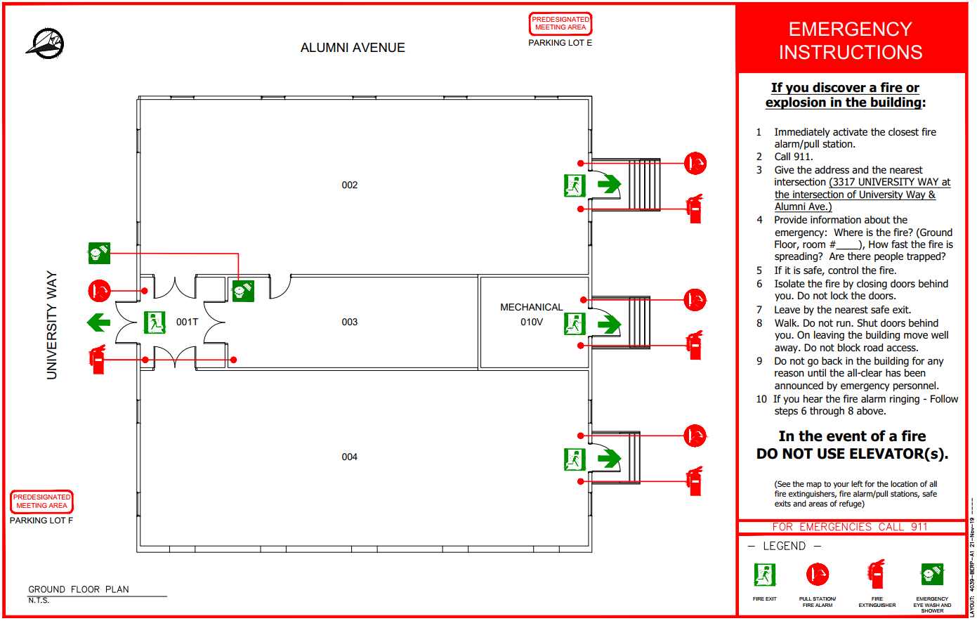

Appendix 3: Building Site Plan

< INSERT BUILDING SITE PLAN MAP >
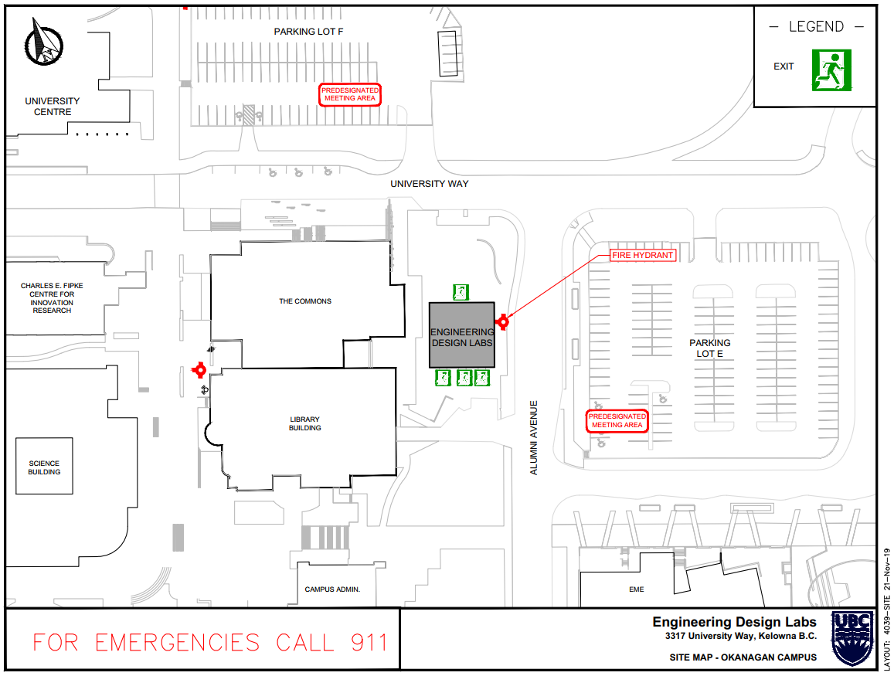

Appendix 4: Inspection, Testing and Maintenance of the Building Fire Protection and Life Safety Systems
The fire code requires that building fire protection and life safety systems receive a variety of regular inspections, service, and maintenance.
- Check – means a visual observation to ensure that devices or systems are in place, and no obvious damage or obstructions to proper operation exist.
- Inspect – means a physical examination to determine that the devices or systems will apparently perform in accordance with its intended function.
- Test – means operation of the devices or systems to ensure that it will perform in accordance with its intended operating functions. It is generally required to have a certified system technician perform tests.
The majority of inspections are generally quick checks to ensure that the particular system is operational and not in need of service. Some inspections do not require a high degree of technical knowledge of the particular system, but rather the ability to check for a specific problem, and have it corrected. Such inspections could be adequately performed by selected supervisory staff on a daily basis.
Semi-Annual and Annual Inspection, Testing and Maintenance procedures generally involve technical procedures and will be performed by qualified individuals or private contractors specializing in the particular field. Contractors may perform their own unique inspection and testing procedures; however, their procedures must meet the minimum requirements set by the applicable code. The repair or cleaning of equipment and the periodic replacement of components must be as per manufacturer's specifications and recommendations and must not reduce the level of performance of the equipment.
When the system or any part of it is shut down, the supervisory staff are to be notified and alternative measures are to be followed as outlined in this approved fire safety plan in accordance with BC Fire Code, Division B, sentence 6.1.1.4 (1) – Protection during Shutdown.
< MODIFY OR DELETE SECTIONS AS NECESSARY >
- Portable Fire Extinguishers
Reference: NFPA 10, Standard for Portable Fire Extinguishers
An inspection of an extinguisher is a quick check that an extinguisher is available and will operate. It is intended to give reasonable assurance that the extinguisher is fully charged and operable. Maintenance is a thorough check of an extinguisher which is intended to give maximum assurance that an extinguisher will operate effectively and safely, and will normally reveal the need for hydrostatic pressure testing. Recharging is the replacement of the extinguishing agent.
- Monthly Inspection
Procedure:
Check portable fire extinguishers for the following:
- Located in designated place
- No obstruction to access or visibility
- Operating instructions on nameplate legible and facing outward
- Seals and tamper indicators not broken or missing
- Determine fullness by weighing or hefting
- Examine for obvious physical damage, corrosion, leakage, or clogged nozzle
- Pressure gauge reading or indicator in the operable range or position
Record Keeping on the Monthly Inspection & Testing Report
- Serial number of extinguishers requiring maintenance should be recorded on report for qualified contractor
Fill-out extinguisher tag with following information:
- Date extinguisher was inspected
- Initials of person performing inspection
- Annual Maintenance
Procedure:
- Perform maintenance in accordance with the B.C. Fire Code Regulations and NFPA 10, including any necessary hydrostatic pressure testing.
Record Keeping on the Annual Inspection & Testing Report
- Means of Egress
- Daily Inspection
Procedure:
- Doors in fire separations shall be inspected to ensure that they remain closed and latched unless the door is equipped with an acceptable hold open device that will permit the door to close and latch automatically in the event of fire.
- Corridors used by the public and exits shall be maintained free of obstructions.
- Exterior passageway and exterior exit stairs shall be maintained free of snow and ice accumulations.
Record Keeping – no formal record keeping required.
- Monthly Inspection
Procedure:
- Doors in fire separations shall be operated to ensure that they are properly maintained.
- Doors equipped with a hold open device must release automatically in the event of a fire.
Record Keeping on the Monthly Inspection & Testing Report

- Fire Detection & Alarm System including Voice Communication
Reference standard: ULC S536, Inspection and Testing of Fire Alarm Systems.
- Daily Inspection
Procedure:
- Check Fire Alarm AC power lamp and trouble light
- Check trouble conditions
- Check central alarm and control facility
Record Keeping – no formal record keeping required.
- Monthly Testing
Procedure:
- Notify the alarm monitoring company, the fire department and the tenants that you are testing the system. Notify all parties when you have completed testing.
- Under emergency power, one manual alarm initiating device shall be operated on a rotation basis and shall initiate an alarm condition
- Intended function of all alarm audible signal appliances shall be ensured
- The annunciator panel shall be checked to ensure that the tested devices annunciate correctly
- Intended function of the audible and visual trouble signals shall be ensured
- Fire alarm batteries shall be checked to ensure that:
  - Terminals are clean and lubricated where necessary
  - Terminal clamps are clean and tight where necessary
  - Electrolyte level and specific gravity, where applicable, are specified by the Manufacturer
Record Keeping on the Monthly Inspection & Testing Report
- Annual Service
Procedure:
- Contractor shall perform service in accordance with ULC S536
Record Keeping on the Annual Inspection & Testing Report

- Emergency Lighting Units
Reference Standard: B.C. Fire Code Regulation - current edition
- Monthly Inspection
Procedure:
- Self-contained emergency lighting unit equipment shall be inspected to ensure that:
  - Pilot lights are functioning and not obviously damaged or obstructed,
  - The terminal connections are clean, free of corrosion and lubricated when necessary,
  - The terminal clamps are clean and tight as per manufacturer=s specifications, and
  - The battery surface is kept clean and dry.
Record Keeping on the Monthly Inspection & Testing Report
- Monthly Testing
Procedure:
- Self-contained emergency lighting unit shall be tested at intervals not greater than one month to ensure that the emergency lights will function upon failure of the primary power supply.
Record Keeping on the Monthly Inspection & Testing Report
- Annual Testing
Procedure:
- Self-contained emergency lighting unit equipment shall be tested at intervals not greater than twelve months to ensure that the unit will provide emergency lighting for a duration equal to the design criterion under simulated power failure conditions. Minimum operating time of___ minutes.
- After completion of the test, the charging conditions for voltage and current and the recovery period shall be tested to ensure that the charging system is functioning in accordance with the manufacturer’s specifications.
Note: Operation time for units is as follows:
- 60 minutes for Group B occupancies not within the scope of Building Code Subsection 3.2.6.
- 30 minutes for a building of any other occupancy.
Record Keeping on the Annual Inspection & Testing Report
- Emergency Generator
Reference Standard: • CAN/ CSA-C282-M, Emergency Electrical Power Supply for Buildings (Hospitals use CAN/ CSA Standard Z32.4)
Emergency power supply is maintained as per the manufacturer’s Manual of Operation.
- Weekly Maintenance Schedule
Procedure: Maintain as per manufacturer’s Manual of Operating Instructions including CAN/CSA S282 Table 2.
- Examine the following:
  - Fuel tank level
  - Lubricating oil level
  - Engine coolant
  - Heaters, lubricant and/or coolant
  - Engine, generator, fuel tanks and cooling systems for evidence of leakage
  - Operation of fuel transfer pump
  - Starting system-batteries, etc., for leakage, cleanliness and terminal security
  - Air tanks for pressure (air motor system)
  - Valves for leakage (air motor system)
  - Operation of auxiliary engine and compressor (air motor system)
  - Bleed off condensation (air motor system)
  - Louvre settings-control panel settings (ensure the unit is ready for start-up)
  - Battery electrolyte level
  - Battery specific gravity
  - Battery electrical connections (tightness, leaks or sulfation)
  - Battery cleanliness and dryness between terminal posts
  - Charger cleanliness and operation of both float and equalize modes
  - Engine governor control linkages and oil level
  - Engine fuel pump oil sump
  - Engine fan belts and protective devices
  - Panel covers are secure and annunciator lamps are operational
Record Keeping: Weekly Inspection Report
- Monthly Testing
Procedure: Maintenance procedures are scheduled and completed as per operating instructions CAN/CSA S282 Table 2.

- Have manufacturer’s maintenance manual and manual of instructions available.
- Simulate a failure of the normal electrical power supply, arranged so that:
  - an engine-generator set operates under at least 30% of the rated load for 60 minutes;
  - all automatic transfer switches are operated under load
- Record readings of all instruments associated with engine and generator and verify that they are normal.
Procedure to Operate Generator (simulate power failure):
- Engage the emergency power transfer switch
- Disengage the switch after completion of test to ensure generator is in normal operating condition.
Record Keeping on the Monthly Inspection & Testing Report
- Monthly Maintenance and Inspection Schedule
- Include an inspection to assess the correct functioning of all auxiliary equipment such as the radiator shutter control, coolant pumps, fuel transfer pumps, oil coolers, and engine room ventilation controls and operation.
- Generator:
  - check brush operation for sparking
  - check for bearing seal leakage
Record Keeping on the Monthly Inspection & Testing Report
- Semi-annual Service
Procedure:
- Check/Clean the following:
  - Crankcase breathers
  - Lubricant governor
  - Linkages
- Annual Maintenance
Procedure:
- Contractor shall perform checking, testing, and servicing of items which require attention at 1 year intervals as specified in the manufacturer’s instructions and CSA Standard C282.
- Liquid fuel storage tank shall be drained and refilled with a fresh supply of fuel at intervals not greater than 12 months.
Record Keeping on the Annual Inspection & Testing Report
- 2 Year Checking
Procedure:
Contractor shall perform checking, testing, and servicing of items which require attention at 2 year intervals as specified in the manufacturer’s instructions and CSA Standard C282.
Record Keeping on the 2 Year Inspection & Testing Report
- 3 Year Checking
Procedure:
Contractor shall perform checking, testing, and servicing of items which require attention at 3 year intervals as specified in the manufacturer’s instructions and CSA Standard C282.
Record Keeping on the 3 Year Test Report
- 5 Year Checking
Procedure:
Contractor shall perform checking, testing, and servicing of items which require attention at 5 year intervals as specified in the manufacturer’s instructions and CSA Standard C282.
Record Keeping on 5 Year Test Report
- Sprinkler System
Reference Standard: B.C. Fire Code Regulation 1998 Section 6.5
Notification - Prior notification of water flow or other tests to be made to a sprinkler system shall be given to parties who could be affected by an alarm.
- Daily Inspection
Procedure:
- Dry-pipe valve rooms or enclosures in unheated building shall be inspected at intervals not greater than 24 hours during periods of freezing weather and measures shall be taken to ensure that the temperature of the room or enclosure is maintained above 4 degrees C.
Record Keeping – no formal record keeping required.
- Weekly Inspection
Procedure:
- Valves controlling sprinkler water supplies or alarms shall be inspected at intervals not greater than 7 days to ensure that they are in the open position.
Note: For valves locked in the open position see Monthly Inspection & Test. For electrical supervised valves see Bi-monthly Test & Inspection.
- Dry pipe system air pressure shall be read at intervals not greater than 7 days and the system shall be maintained at the required pressure.
Record Keeping: Weekly Inspection Report
- Monthly Inspection & Tests
Procedure:
- When the alarm line discharge is subject to freezing, water flow alarm tests using the alarm test connection located at the sprinkler valve shall be performed on sprinkler systems at intervals not greater than one month. (This test operates mechanical or electrical gong.)
- On monitored system, the water flow actuated devices may be tested every two months. See Bi-monthly Test and Inspection.
- On electrically supervised systems, the water flow actuated devices may be tested annually. See Annual Tests and Maintenance.
- Valves which are locked open shall be inspected at intervals not greater than one month.
- Check the priming water supply for dry-pipe systems to ensure that it is at the proper level above the dry-pipe valve.
Record Keeping: Monthly Inspection & Testing Report
- Bi-monthly Test and Inspection
Procedure:
All Sprinkler Systems
- Transmitters & water flow actuated devices shall be tested at intervals not greater than 2 months for system connected to electrical supervisory signal service. (Example: fire alarm system or central station monitoring service.)
- Inspect all electrically supervised control valves.
Record Keeping on Bi-monthly Testing Report
- Semi-annual Tests
Procedure:
All Systems
- Gate valve supervisory switches, tank water level devices, building and tank water temperature supervisory devices and other sprinkler supervisory devices shall be tested at intervals not greater than 6 months.
Record Keeping on Semi-Annual Inspection & Testing Report
- Annual Tests & Maintenance
Procedure:
Wet Systems
- Water flow alarm tests using the inspector’s test connection shall be performed on wet pipe sprinkler systems at intervals not greater than twelve months.
Dry Systems
- Dry-pipe valves shall be trip tested at intervals not greater than 12 months with the control valve partially open. (Dry-pipe valves shall be trip tested at least once every 3years with the control valve fully open using the inspector’s test valve.)
- Auxiliary drains shall be drained before each winter.
All Systems
- Water flow tests using the main drain shall be conducted at intervals not greater than 12 months to ensure that water supply available has not deteriorated.
- Drainage facilities shall be tested to ensure that the drains are capable of taking the full flow from the main drain pipe without causing damage.
- Sprinkler control valves are accessible.
- Pits containing sprinkler control valves are free of water and protected from freezing.
- Sprinkler piping and hangers are in good repair.
- Sprinklers are inspected for damage, corrosion or accumulations of grease, paint or other deposits and are replaced where such conditions would impair the operation of the sprinkler.
- Spare sprinklers shall be checked to ensure that the stock on hand is not less than:
  - 6 spare sprinklers (not more than 300 sprinklers)
  - 12 spare sprinklers (between 301 - 1 000 sprinklers)
  - 24 spare sprinklers (more than 1 000 sprinklers)
- Spare sprinklers shall correspond to the types and temperature ratings of the sprinklers in use.
- A sprinkler wrench shall be kept in the cabinet where the spare sprinklers are stored.
Record Keeping on Annual Inspection & Testing Report
- Three Year Test
Procedure:
Dry System
- Dry-pipe valve shall be trip tested with the control valve fully open using the inspector’s test pipe (dry-pipe valve shall be trip tested annually with the control valve partially open).
Record Keeping on 3 Year Test Report
- Fifteen Year Test
Procedure:
Dry System
- Entire system shall be test flushed at intervals not greater than 15 years.
NOTE: Whenever any of the regularly scheduled testing procedures indicate the presence of possible obstructions in the dry pipe system piping, the entire system shall be flushed of foreign material.
Record Keeping on Fifteen Year Testing Report
- Fifty Year Test
Procedure:
- Sample sprinklers from sprinkler systems which have been in service more than 50 years shall be sent to a recognized testing laboratory for testing, and this procedure shall be repeated at intervals not greater than10 years thereafter.
- When sprinklers are required to be tested in conformance with Sentence (1), no fewer than 6 sprinklers of each type shall be tested, except that no fewer than 2 sprinklers per floor per individual system shall be tested.
- All sprinklers shall be replaced in sprinkler systems from which sample sprinklers have been tested and found defective.
Record Keeping on Fifty Year Test Report
- Standpipe & Hose System
Reference Standard: NFPA 14, Installation of Standpipe and Hose System.
Alterations - Standpipe systems that have been modified or extended or are being restored to service after a period of disuse exceeding twelve months, shall be flow and pressure tested at the highest and most remote hose connection to ensure the availability of the water supply for which the system was designed.
- Monthly Inspection
Procedure:
- Hose cabinets shall be inspected to ensure that the hose is in proper position and that all of the equipment is in place and in operable condition.
- Hose valves shall be checked to ensure they are tight.
- Main shut off valve shall be checked to ensure that it is open.
Record Keeping on Monthly Inspection & Testing Report
- Annual Inspection
Procedure:
- All portions of the system shall be inspected.
Record Keeping on Annual Inspection & Testing Report
- Five Year Test
Procedure:
- The standpipe system shall be flow tested at intervals not greater than 5 years to ensure that the design flow can be delivered.
- If during the flow test there is an identification of the presence of debris in the piping, the entire system shall be flushed of foreign material.
Record Keeping on the Five Year Test Report.
Record Keeping on Annual Inspection & Testing Report
- Fire Dampers & Fire Stops Flaps
- Annual Testing
Procedure:
- Ensure that the fire dampers and fire stops are in place and are not obviously damaged or obstructed.
Record Keeping on the Annual Inspection and Testing Report.
- Hoods, Ducts & Filters
- Weekly Inspection
Procedure:
- Hoods, ducts and filters subject to accumulations of combustible deposits shall be inspected at intervals not greater than 7 days, and shall be cleaned if the accumulation of such deposits creates a fire hazard.
- If necessary hoods and filters shall be cleaned by staff.
- If necessary ducts shall be cleaned by a qualified contractor.
Record Keeping on the Weekly Inspection & Testing Report - when equipment is cleaned.
- Heating Ventilating & Air Conditioning Systems
- Annual Testing and Servicing
Procedure:
- Inspect and service as necessary to ensure that these systems do not create a fire hazard.
- Except for self-contained systems within dwelling units, disconnect switches for mechanical air-conditioning and ventilating systems shall be operated to establish that the system can be shut down in an emergency.
Record Keeping on the Annual Inspection & Testing Report.
- Fire Department Access to Building
- Daily Inspection
Procedure:
- Streets, yards and roadways provided for fire department access shall be maintained so as to be ready for use at all times by fire department vehicles.
- Vehicles shall not be parked to obstruct access of fire department vehicles and signs shall be posted prohibiting such parking.
- Access panels or windows provided to facilitate access for firefighting operations shall be maintained free of obstructions at all times.
Record Keeping – no formal record keeping required.

Appendix 5: BC Fire Code 2018 Excerpt

British Columbia Fire Code 2018, Section 2.8 Emergency Planning

    - General
      - Application
- Fire emergency procedures conforming to this Section shall be provided for
  - every building containing an assembly, care, treatment or detention occupancy
  - every building required by the British Columbia Building Code to have a fire alarm system,
  - demolition and construction sites regulated under Section 5.6.,
  - storage areas required to have a fire safety plan in conformance with Articles 3.2.2.5. and 3.3.2.9.,
  - areas where flammable liquids or combustible liquids are stored or handled, in conformance with Article 4.1.5.5., and
  - areas where hazardous processes or operations occur, in conformance with Article 5.1.5.1.
      - Training of Supervisory Staff
- Supervisory staff shall be trained in the fire emergency procedures described in the fire safety plan before they are given any responsibility for fire safety. (See Note A-2.8.1.2.(1).)
      - Keys and Special Devices
1) Any keys or special devices needed to operate the fire alarm system or provide access to any fire protection systems or equipment shall be readily available to on-duty supervisory staff.

    - Fire Safety Plan
      - Measures in a Fire Safety Plan
- In buildings or areas described in Article 2.8.1.1., a fire safety plan conforming to this Section shall be prepared in cooperation with the fire department and other applicable regulatory authorities and shall include
  - the emergency procedures to be used in case of fire, including
    - sounding the fire alarm (see Note A-2.8.2.1.(1)(a)(i)),
    - notifying the fire department,
    - instructing occupants on procedures to be followed when the fire alarm sounds,
    - evacuating occupants, including special provisions for persons requiring assistance (see Note A-2.8.2.1.(1)(a)(iv)),
    - confining, controlling and extinguishing the fire,
  - the appointment and organization of designated supervisory staff to carry out fire safety duties,
  - the training of supervisory staff and other occupants in their responsibilities for fire safety,
  - documents, including diagrams, showing the type, location and operation of the building fire emergency systems,
  - the holding of fire drills,
  - the control of fire hazards in the building, and
  - the inspection and maintenance of building facilities provided for the safety of occupants.
(See Note A-2.8.2.1.(1).).
- The fire safety plan shall be reviewed at intervals not greater than 12 months to ensure that it takes account of changes in the use and other characteristics of the building.
      - Care, Treatment and Detention Occupancies
- A sufficient number of supervisory staff shall be on duty in care, treatment and detention occupancies to perform the tasks outlined in a fire safety plan described in Clause 2.8.2.1.(1)(a).
      - Assembly Occupancies
- In Group A, Division 1 assembly occupancies containing more than 60 occupants, there shall be at least one supervisory staff member on duty in the building to perform the tasks outlined in the fire safety plan in Clause 2.8.2.1.(1)(a) whenever the building is open to the public.
      - High Buildings
- In buildings within the scope of Subsection 3.2.6. of Division B of the British Columbia Building Code, the fire safety plan shall, in addition to the requirements of Sentence 2.8.2.1.(1), include
  - the training of supervisory staff in the use of the voice communication system,
  - the procedures for the use of elevators,
  - the action to be taken by supervisory staff in initiating any smoke control or other fire emergency systems installed in a building in the event of fire until the fire department arrives,
  - instructions to the supervisory staff and fire department for the operation of the systems referred to in Clause (c), and
  - the procedures established to facilitate fire department access to the building and fire location within the building.
      - Retention of Fire Safety Plans
- The fire safety plan shall be kept in the building for reference by the fire department, supervisory staff and other personnel.
- The fire safety plan for a building within the scope of Subsection 3.2.6. of Division B of the British Columbia Building Code shall be kept at the central alarm and control facility.
- The fire safety plan for a building or facility within the scope of Sections 3.1., 4.1., and 5.1. shall be kept at the principal entrance to the building or facility.
      - Distribution
- A copy of the fire emergency procedures and other duties for supervisory staff, as laid down in the fire safety plan, shall be given to all supervisory staff.
      - Posting of Fire Emergency Procedures
- At least one copy of the fire emergency procedures shall be prominently posted on each floor area.
- In every hotel and motel bedroom the fire safety rules for occupants shall be posted showing the locations of exits and the paths of travel to exits.
- Where a fire alarm system has been installed with no provisions to transmit a signal to the fire department, a sign shall be posted at each manually actuated signaling box requesting that the fire department be notified, and including the telephone number of that department.
- All buildings served by one or more elevators shall have, at each elevator entrance on each floor level, a permanently mounted fire safety sign or symbol indicating that the elevator is not to be used in case of fire.
- The sign or symbol required by Sentence 2.8.2.7. (4) shall be at least 100 mm in height and width and shall be designed in accordance with NFPA 170 “Standard for Fire Safety and Emergency Symbols”.

    - Fire Drills
      - Fire Drill Procedures
- The procedure for conducting fire drills shall be determined by the person responsible in charge of the building, taking into consideration
  - the building occupancy and its fire hazards,
  - the safety features provided in the building,
  - the desirable degree of participation of occupants other than supervisory staff,
  - the number and degree of experience of participating supervisory staff,
  - the features of fire emergency systems installed in buildings within the scope of Subsection 3.2.6. of Division B of the British Columbia Building Code, and
  - The requirements of the fire department.
(See Note A-2.8.3.1.(1).)
      - Fire Drill Frequency
- Except as provided in Sentence (2), fire drills as described in Sentence 2.8.3.1.(1) shall be held at intervals not greater than 12 months for the supervisory staff, except that
  - in daycare centres and in Group B major occupancies, such drills shall be held at intervals not greater than one month,
  - in schools attended by children, total evacuation fire drills shall be held at least 3 times in each of the fall and spring school terms, and
  - In buildings within the scope of Subsection 3.2.6. of Division B of the British Columbia Building Code, such drills shall be held at intervals not greater than 2 months.
- Fire drills in a laboratory shall be held at intervals not greater than 3 months.

Appendix 6: Operating a Fire Extinguisher

The following instructions are applicable for most fire extinguishers. When faced with a situation where a fire extinguisher may be an appropriate means of dealing with a fire, you must first determine that your personal safety will not be compromised by doing so. Don’t attempt to fight a fire unless the fire alarm has been sounded, the fire is small and contained, you have a safe egress route and the available extinguisher is rated for the size and type of fire.

If you do not feel confident using a fire extinguisher or if you feel that you cannot safely fight the fire, you should concentrate on a safe evacuation of your area of responsibility.

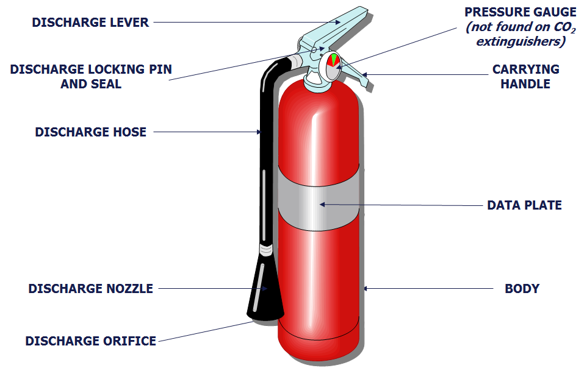

If you determine that it is safe to use a fire extinguisher, remember the acronym PASS –

Pull the pin – Fire extinguishers often have a pin, latch, or puncture lever that you need to release first.
Aim low – Aim the nozzle or hose of the extinguisher at the base of the fire.
Squeeze the handle – This releases the extinguishing agent.
Sweep from side to side – Move in close, and sweep across the base of the fire. Always back away and watch for rekindling of the fire.

Discharge the entire contents of the extinguisher. If possible to do without compromising your safety, pull apart the burned area to get at hot spots.

After the fire has been extinguished, immediately contact Facilities Management at 250-807-9272 to arrange for the fire extinguisher to be recharged/replaced.

*Foam and water extinguishers require a slightly different technique. Always read the instructions on the label before you need to use a fire extinguisher.

Appendix 7: Persons Requiring Assistance

Scope
Persons with the following five general disabilities may apply to this section: mobility, visual, hearing, speech, and cognitive. Building Occupants who can relate to any of these general disabilities should develop an evacuation plan prior to an emergency evacuation. This plan should be documented (e.g. on page 10 of this document).

In any case, when a Building Occupant is left in the building during an emergency evacuation the Emergency Warden, the Building Emergency Director, and then the Fire Department need to be immediately notified.

Persons Providing Assistance
Predetermined persons providing assistance can be anyone in the office or building such as a co-worker, friend, building staff, supervisor, Emergency Warden, etc. Whether one person or multiple people are required to provide assistance, alternate people should be identified and this information should be recorded in the FSP/BERP and/or other written plans. Additionally, the time the person providing assistance is expected to wait at an Area of Refuge during an emergency evacuation should be discussed during the planning and training stages.

Type of assistance provided includes:
- Guidance
  - Explaining information about where to go, the type of emergency occurring, and what needs to be done
  - Escorting the persons to the Area of Refuge or to the exit.
- Minor Physical Effort
  - Offering an arm to assist the persons
  - Opening the door(s).
- Major Physical Effort
  - Operating a stair-descent device
  - Participating in carrying a wheelchair down the stairs
  - Carrying a person down the stairs.
Where will the person(s) start providing assistance?
- From the location of the Person Requiring Assistance
  - The person providing assistance and the person requiring assistance should determine the best method for communication (face-to-face, phone, e-mail, etc.) prior to an emergency evacuation.
- From a specific, predetermined location such as the entry to the stairs.
How will the person(s) providing assistance be contacted?

- Face-to-face
- Phone
- E-mail.

When will the person(s) provide assistance?

- Always
- Only when asked.

Mobility
Mobility impairments include individuals with wheelchairs, individuals whom can walk but with difficulty, individuals whom have difficulty using building features such as stairs, individuals with respiratory impairments, etc. Additionally, persons with mobility impairments can hear standard alarms and voice announcements and can see activated visual notification appliances (strobe lights) that warn of danger and the need to evacuate.

People with any type of mobility impairments should be provided with written plan and/ or a map showing all emergency evacuation routes including alternate evacuation routes (See Appendix 7: Personal Emergency Plan Template). Plans should include information on assistance devices (i.e. where they are kept, how to use them, etc.) and/ or the type of method used to carry an individual (e.g. cradle carry or swing carry), if applicable. Training, practice, and an understanding of the benefits and risks of using assistance devices and/ or carrying methods are important and necessary aspects of the planning process.

Important notes:
- Persons with mobility impairments may require assistance with operating door locks, latches, and other devices due to impairments of their hands, fingers, legs, feet, or arms.
- Persons with mild to severe mobility impairment may require assistance to exit the building. A personal evacuation plan should be developed.

Mobility - Overview
- Persons with mobility challenges:
  - Pre-plan what you will do if there is an emergency in your building and know the exit routes available.
  - If no exit is available then find a safe place (no apparent danger, has communications and someone knows where you are)
    - If you are in one, stay there.
    - If not, move to a safe place in a different part of the same floor.
  - In either event, ensure that someone (ideally a supervisor) knows exactly where you are and plans to tell a first responder as soon as they exit.
- Supervisors/instructors:
  - Know the layout of your buildings, any exit challenges and potential safe places.
  - Know what you would do if an evacuation occurs and you have folks in your area of responsibility that have mobility challenges.
  - Know and be able to describe (room numbers, etc.) exactly where any mobility-challenged people have elected to await rescue.
  - Make sure to tell the first emergency responder you see in detail and make sure action is being taken.

Mobility - Definitions
- Horizontal Evacuation - This means moving away from the area of danger to a safer place on the same floor where the individual is at the time of the alarm or emergency. This type of evacuation may be required in situations where the individual cannot use exit stairs to get to the outside and must remain on a particular floor until assistance arrives. In this case, the individual should move away from the area of imminent danger (detectable smoke, fire, or unusual odor) to a safe distance (i.e., another wing, the opposite end of the corridor, or outside).
- Stay in Place - In certain cases, individuals may not be able to move to another location. Unless danger is imminent, the individual should remain in a room with an exterior window and a phone, closing the door if possible. Contact Campus Security’s emergency line (250-807-8111) and give your name, location, and reason you are calling. Phone lines normally remain in service during building emergencies. If the phone line fails, an individual can contact Campus Security via their mobile phone, or signal from the window by waving a cloth or other visible item.

Mobility - Pre-Planning
When a person with mobility challenges regularly works in specific areas (e.g. worker, student with a classroom and lab schedule, etc.), plans should be proactively developed to address specific needs, possible egress challenges, appropriate evacuation routes and locations, and a communication plan. Assistance in the planning process can be provided by the Disability Resource Centre as well as Health, Safety & Environment. Horizontal evacuation routes/destinations should be the first priority, followed by “staying in place” planning.

Mobility - When No Pre-Plan Exists
In situations where visitors with mobility challenges are on campus or if a student or staff member with mobility challenges is not in (one of) their regular location(s), general principles will apply. Emergency Wardens may be the primary contact point in an emergency evacuation situation and thus it is important for Wardens to familiarize themselves with layout details of the areas they are responsible for. If a person with mobility challenges is present when a building is evacuated, the Warden will direct that person to the area of the floor furthest away from the risk/hazard.

Mobility - Key Points
- When pre-planning for a specific person, make two plans - one for use if the person can be assisted by others and one for if they are alone (would be part of “Working Alone” procedure).
- Two different evacuation routes should be planned for each location; elevators and dead-end locations must be avoided.
- Consider implications/needs if egress route could be through closed fire doors without accessible opening hardware.
- It is prudent for persons with mobility challenges to carry personal mobile phones in case building phones do not work or are not present.
  - Register your mobile phone for UBC ALERT notifications (http://emergency.ok.ubc.ca/ubcalert.html), download UBC SAFE app (http://www.apparmor.com/clients/ubc.ca/) and pre-program emergency numbers into your contact list.
- Persons with mobility challenges should consider carrying bright, adhesive door/window markers to make it easier for emergency personnel to find them.
- “Communication plan” can be as simple as setting up a buddy system.

Visual
Persons with visual impairments (i.e. blind or with low vision) can hear standard building fire alarms and voice announcements that warn danger or the need to evacuate or that provide instructions. On the other hand, persons with visual impairment may not be able to evacuate on their own. It is important to verify prior to an emergency evacuation if persons with visual impairments can evacuate unassisted or not (this information should be detailed in a personal evacuation plan).

Important notes:
- Exit signage and directional signage for those with visual impairments is clearly and strictly specified by codes (requirements include type, size, spacing, color of letters, etc.). Tactile signage must be designed and properly located so they can be readily found by a person with a visual impairment from any direction of approach to the exit access.
- If tactile signage is used in the workplace, it may be practical to physically take persons with visual impairments to these areas.
- During an emergency evacuation, pre-determined evacuation routes may be obstructed, persons with visual impairment will need to know if an alternate route should be taken.

The personal evacuation plan for a person with a visual impairment needs to be prepared and kept in the alternative format preferred by that person, including but not limited to Braille, large type, or tactile characters.

Hearing
Persons with hearing impairments cannot hear alarms and voice announcements that warn of danger and the need to evacuate. Many codes require new buildings to have flashing strobe lights (visual devices) as part of the standard building alarm system, but because the requirements are not retroactive many buildings do not have them. Additionally, strobe lights are required only for fire alarm systems and simply warn that there may be a fire, and not for other type of emergency evacuations systems.

It is extremely important for people with hearing impairments to know what visual notification systems are in place. They need to be aware of which emergencies will activate the visual notification systems and which emergencies will not. Alternative methods of notification need to be put in place in your workplace for people with hearing impairments so they can get all the information they need to evacuate in a timely manner.

Once notified, people with hearing impairments can read and follow standard exit and directional signs.

Important notes:
- If a person with a hearing impairment is likely to be in one location for a significant period of time, such as at a desk in an office, installation of a reader board in the work area might be useful.
- Other notification methods include personal notification devices which can be activated by a building’s alarm system, instant email, or phone communications.

Speech
People with speech impairments can hear standard alarms and voice announcements and can see visual indicators that warn of danger and the need to evacuate. Once notified, people with speech impairments can use any standard means of egress and can read and follow standard exit and directional signs.

Elevators are required to have both a telephone and an emergency signaling device. People with speech impairments should be aware of whether the telephone is limited to voice communications and where the emergency device rings - whether it connects or rings inside the building or to an outside line - and who would be responding to it. Additionally, they may need some assistance with voice communication devices in an elevator.

Cognitive
Persons with cognitive impairments can understand hear standard alarms and voice announcements and see visual indicators that warn of danger and the need to evacuate. However, they may not have the ability to recognize and understand emergency alarm systems or other emergency features and what they mean. If person does not recognize and understand alarms systems or emergency features, then plans need to be developed.

Cognitive impairments prevent a person from using or accessing building features due to an in an inability to process or understand the information necessary to use the features. In general, persons with cognitive impairments have some decreased level of ability to process or understand information or situations. It should be verified whether a person with a cognitive impairment has the ability to find and use the exits. If not, plans for assistance need to be developed.

Possible accommodations for emergency evacuation for people with cognitive impairments:
- providing a picture book of drill procedures and/ or simple floor plans
- colour-coding fire doors and exit ways
- implementing a buddy system
- using a job coach for training

Contact Information
- Disability Resource Centre: 250-807-8053, drc.questions@ubc.ca
- Dept. of Health, Safety & Environment: 250-807-8859, hse.ok@ubc.ca

Appendix 8: Personal Emergency Plan Template

TYPE OF ASSISTANCE NEEDED
Does the person require a device or aid? If yes, what and where is the specific device or aid?
Does the person need assistance to evacuate? |  | Number assistants needed:
What does the assistant(s) need to do, does the assistant(s) need any training, has the training for the assistant(s) been completed?
Where will the assistant(s) meet the person requiring assistance? When will the person requiring assistance contact the assistant(s)? How will the assistant(s) be contacted in an emergency? (e.g. e-mail, phone, visual)
Name (indicate if primary or alternate assistant) | Phone |  | Cell Phone | E-mail

Other details (e.g. service animals):

NOTE: To respect personal privacy, please obtain consent from each of the individuals indicated on the tables above prior to posting a public copy of the Building Emergency Response Plan and/or Personal Emergency Plan on a safety or information board within your building. If full consent is not available, please remove this page prior to posting.

Appendix 9: Definitions

Alarm Signal: A signal, indicating an emergency requiring immediate action, such as: Alarm for Fire, from a manual box, Water Flow Alarm, Alarm from an automatic Fire Alarm System, and Other Emergency Signal.

Automatic Heat Tape: Electric wire is wrapped around water-filled piping located in unheated areas. The wire is generally located underneath an insulating layer of fiberglass, and automatically keeps the water in the pipe from freezing.

Building Code Subsection 3.2.6: A subsection of the building code which has requirements applicable only to high buildings such as high rises and some large institutions.

Class “A” Fire: A fire involving combustible materials such as wood, cloth and paper.

Class “B” Fire: A fire involving flammable or combustible liquid, fat or grease.

Class “C” Fire: A fire involving energized electrical equipment.

Closure: A device or assembly for closing an opening through a fire separation such as: Door, Shutter, Wired Glass, or Glass Block, and includes all components such as Hardware, Closing Devices, Frames and Anchors.

Combustible Construction: Type of construction that does not meet the requirements for non-combustible construction.

Combustible Liquid: Any liquid having a flash point at or above 37.8ºC and below 93.3ºC.

Compressed Gas: Any contained mixture or material with either an absolute pressure exceeding 275kPa at 54ºC or both, or any liquid having an absolute vapour pressure exceeding 275kPa at 38ºC.

Corrosive Liquid: Any liquid which when contacting living tissue causes damage to the tissue or when contacting organic matter and certain chemicals causes fire.

Deputy Emergency Director: An appointed supervisory staff member who assumes the duties of the Emergency Director during his/her absence.

Dry Automatic Sprinkler System: A fire sprinkler system which has sprinkler supply piping containing air. Such a system can be installed in areas subjected to freezing conditions as water does not enter the sprinkler piping until a sprinkler activates.

Emergency Director: An appointed supervisory staff member.

Exhaust Duct: A duct through which air is conveyed from a room or space to the outdoors.

Exit: That part of a means of egress that leads from the floor area it serves, including any doorway leading directly from a floor area to a public thoroughfare or to an acceptable open space.

Exit (Horizontal): The type of exit connecting two (2) floor areas at substantially the same level by means of a doorway, vestibule, bridge, or balcony, such as floor areas being located whether in different buildings or located in the same building and fully separated from each other by a fire wall.

Exit (Level): The lowest level in an enclosed exit stairway from which an exterior door provides access to a public thoroughfare or to an acceptable open space with access to a public thoroughfare at approximately the same level either directly or through a vestibule or exit corridor.

Fire Compartment: An enclosed space in a building that is separated from all other parts of the building by enclosing construction providing a fire separation having a required fire resistant rating.

Fire Damper: A closure which consists of a normally held open damper installed in a distribution system or in a wall or floor assembly and designed to close automatically in the event of a fire in order to maintain the integrity of the fire separation.

Fire Protection Rating: The time in hours or fraction thereof that a closure will withstand the passage of flame when exposed to fire under specified conditions of test and performance criteria.

Fire Protection Systems: A general term used in this document which includes sprinkler and fire alarm systems, hose stations, portable fire extinguishers, fire dampers, emergency lights, exit signs, fire doors, smoke control equipment, and voice communication systems.

Fire Resistance: The property of a material assembly to withstand fire or give protection from it as applied to elements or building. It is characterized by the ability to confine a fire or continue to perform a given structural function or both.

Fire Resistance Rating: The time in hours that a material or assembly of materials will withstand the passage of flame and the transmission of heat when exposed to fire.

Fire Safety Plan: A plan which provides occupant information for control of fire hazards, maintenance of fire protection systems, and evacuation procedures for their building.

Fire Separation: A construction assembly that acts as a barrier against the spread of fire and may not be required to have a fire resistance rating or a fire protection rating.

Fire Stop: A device intended for use in horizontal assemblies required to have a fire resistance rating and incorporating protective ceiling membranes which operates to close off a duct opening through the membrane in the event of a fire.

Firewall: A type of fire separation of non-combustible construction which subdivides a building or separates adjoining buildings to resist the spread of fire and which has a fire resistance rating and structural stability to remain intact for the required fire rated time.

Flame Spread Rating: An index or classification indicating the extent of spread-of-flame on the surface of a material or an assembly of materials as determined in a standard fire test.

Flammable Liquid: Any liquid having a flash point below 37.8ºC.

Flash Point: The minimum temperature at which a liquid within a container gives off vapour in sufficient concentration to form an ignitable mixture with air near the surface of the liquid.

Floor Of Activation: The floor from which the fire alarm has been activated.

Flue: An enclosed passageway for conveying flue gases.

Flue Pipe: The pipe connecting the flue collar of an appliance to a chimney.

Furnace: A space-heating appliance using warm air as the heating medium and usually provisioned for the attachment of ducts.

Group “A” Occupancy: An assembly type occupancy such as a hall, theatre, skating rink or other place of public amusement.

Group “B” Occupancy: An institutional type occupancy such as a hospital, jail or care facility for the aged.

Heat Detector: A device for sensing an abnormally high increase in air temperature initiating a signal indicating this condition.

Interconnected Floor Space: Superimposed floor area or parts of floor areas in which floor assemblies that are required to be fire separations are penetrated by openings that are not provided with closures.

Lower Explosive Limit: The minimum concentration of vapour in air at which the propagation of flame occurs on contact with a source of ignition.

Low Pressure Storage Tank: A storage tank designed to operate at pressures from 3.5kPa (gauge) to 100kPa (gauge).

Major Occupancy: The principal occupancy for which a building or part thereof is used or intended to be used and shall be deemed to include the subsidiary occupancies which are an integral part of the principal occupancy.

Means Of Egress: A continuous path of travel provided by a doorway, hallway, corridor, exterior passageway, balcony, lobby, stair, ramp, or other egress facility or combination thereof, for the escape of persons from any point in a building, room or contained open space to a public thoroughfare or other acceptable open space (means of egress includes exists and access to exits).

NFPA: National Fire Protection Association.

Non-Combustible Construction: All type of construction in which a degree of fire safety is attained by use of non-combustible materials for structural members and other building assemblies.

Oxidizing Materials: A material, other than ordinary atmospheres, which by itself is not necessarily combustible, but which may generally by yielding oxygen, cause or contribute to the combustion of another material.

Partition: An interior wall one (1) storey or part-storey in height that is not load-bearing.

Plenum: A chamber forming part of an air duct system.

Pressure Vessel: A storage tank designed to operate at pressures greater than 100 kPa (gauge).

Proprietary Control Centre: A continually supervised station under the control of the owner or others interested in the building to be protected that conforms with Class “A” proprietary signaling systems in NFPA-72D-1975 installation, maintenance, and use of proprietary protective signaling systems for watchman, fire alarm, and supervisory service.

Public Corridor: A corridor that provides access to exit from more than one (1) suite.

Qualified Contractor: A specific service agency, trained industrial safety personnel or maintenance personnel. Generally any trained person with proper equipment.

Return Duct: A duct for conveying air from space being heated, ventilated or air conditioned back to the heating, ventilating or air-conditioned appliance.

Smoke Alarm: A combined smoke detector and audible alarm designed to sound an alarm within the room or suite in which it is located upon the detection of smoke within that room or suite.

Smoke Detector: A device for sensing the presence of visible or invisible particles produced by combustion, and automatically initiating a signal indicating this condition.

Sprinklered: The building or part thereof is equipped with a system of automatic fire sprinklers.

Standpipe System: An arrangement of piping, valves, hose connections and allied equipment installed in a building with the hose connections located in such a manner that water can be discharged in streams or spray patterns through attached hose and nozzles, for the purpose of extinguishing a fire and so protecting a building and its contents in addition to protecting occupants. This is accomplished by connections to water supply systems or by pumps, and other equipment necessary to provide an adequate supply of water to the hose connections.

Supervisory Signal: A signal indicating the need for action in connection with the supervision of sprinkler and other extinguishing systems or equipment or with the maintenance features of other protection systems.

Supervisory Staff: Those occupants of a building who have some delegated responsibility for the emergency procedures of other occupants under the emergency plan may also refer to the local fire department where it assumes these responsibilities.

UL: Underwriters Laboratories Inc. (U.S.A.)

ULC: Underwriters Laboratories of Canada.

Unstable Liquid: A liquid, including flammable and combustible liquids which are chemically reactive to the extent that they will vigorously react or decompose at or near normal temperature or pressure conditions or which is chemically unstable when subjected to impact.

Vertical Service Space: A shaft oriented essentially vertically that is provided in a building to facilitate the installation of building services including mechanical, electrical and plumbing installations and facilities such as elevators.

Wet Sprinkler System: A fire sprinkler system which has sprinkler supply piping containing water. Such a system cannot be installed in areas subjected to freezing conditions as water is always in the sprinkler piping.

