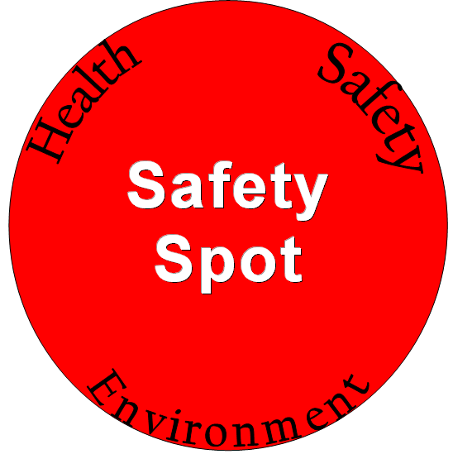

Laboratory Guidelines
Please post in the lab

- No eating, drinking or gum chewing within the lab.
- Doors should remain closed at all times. Ventilation works properly only when the doors are shut.
- No food or food wrappers/containers are permitted inside the lab.
- No mouth pipetting.
- Wash hands regularly, such as when exiting or entering the lab, after spill clean-up or changing tasks.
- Restrain dangling clothing, hair, or jewellery.
- Laboratory clothing should be loose fitting.
- Consider the safety of those around: inform others if you are engaging in hazardous work.
- Follow the laboratory working alone policy.
- Ensure your Personal Protective Equipment (PPE) is appropriate to the hazard in the lab. Protective equipment should match the most hazardous activity in a room.
- Pets are not permitted in the laboratory.
- Keep up to date emergency information near the telephone and update it periodically.
- Keep spill containment materials in the lab and check regularly.
- Inspect and maintain equipment ensuring that safety guards and other protective features are always in place.
- Before you open a chemical ensure you understand the risks, have taken WHMIS training and have the appropriate safety precautions in place.
- In this lab, the following individuals are responsible for ordering materials:
  - Name
- Put the date and your initials on a chemical when it is received, and opened.
- Hazardous materials NEVER go down the sink or into the general waste stream.
- Consider scaling down procedures to limit your exposure to hazardous materials, and limit the amount of wastes for disposal.
- Use diluted substances more often.

The PI in this lab has set the following laboratory guidelines:
- Add lab specific rules here.

